
Critical And Creative Thinking Skills For Decision-Making And Problem-Solving
2017

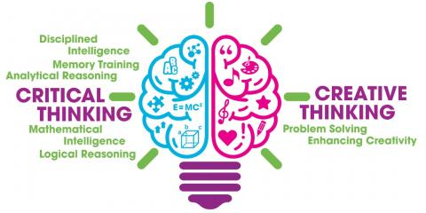
Bursatra

COURSE INTRODUCTION

Both critical and creative thinking skills are needed for making good judgements, decisions, and problem-solving. Critical thinking refers to the ability to use deductive and inductive reasoning in order to assess inferences made, and hence to either accept or reject them. We often come to conclusions through a process of deductive/inductive reasoning, without making them explicit and checking whether they are acceptable on logical grounds. In this course we will learn to assess claims made, by checking the process or structure of inference, and examining their validity through the application of the rules of logic.

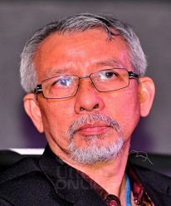
In contrast to critical thinking, however, there are no explicit rules for creative thinking, but there are certain ‘heuristics’ or guidelines/’rules of thumb’, which can be applied to creatively solve problems, and come up with new ideas. In this regard we will look at ‘lateral thinking’, ‘mind-mapping’, and ‘heuristic reasoning’, as forms or techniques of creative thinking.

COURSE OBJECTIVES

- The course will enable participants to evaluate claims made by examining the logical structure of the inferential chain that led to the claim or conclusion made.
- To look at examples of how critical thinking skills can help to avoid mistakes in decision-making.
- To introduce participants to some of the principles and examples of creative thinking in a variety of situations.

COURSE COVERAGE

- To identify the presence of conclusions or claims made, and the reasoning offered in its support.
- To evaluate whether the reasoning offered in support of a conclusion is sound or flawed.
- To look at some examples of causal explanations, and the criteria for its evaluation.
- To examine assumptions made, and to check the reliability of sources of information.
- To introduce participants to some of the principles and practices of forms of creative thinking such as lateral thinking, heuristic reasoning, and mind-mapping.
WHO SHOULD ATTEND

Companies Directors, Company Secretaries, Academicians and Key Personnel in Companies.
COURSE METHODOLOGY

Lectures facilitated by PowerPoint presentation and discussion using case studies.
4 CEP HOURS
ADMINISTRATIVE DETAILS

DATE | : | 28 Mar / 17 Apr  04 May 2017
DURATION | : | Half-Day(0900 - 1300 hours)
VENUE | : | Hilton Petaling Jaya
FEE | : | RM932.80 per participant (fee is inclusive of 6% GST)
PAYMENT | : | Cheque is to be made payable to BURSATRA SDN. BHD.
PRESENTER’S PROFILE

PROF. DR. MOHD HAZIM SHAH ABDUL MURAD
PhD, History and Philosophy of Science, University of Pittsburgh

Dr. MOHD HAZIM SHAH holds a Bachelor’s degree in Liberal Studies in Science from Manchester University, England, a Master’s degree in Philosophy from the London School of Economics, and a PhD in the History and Philosophy of Science from the University of Pittsburgh, U.S.A. In 1993 he was a Visiting Research Fellow at the Department of History & Philosophy of Science, University of Melbourne, Australia, and spent time as a Visiting Scholar at the Department of History and Philosophy of Science, University of Cambridge, in 2008.

He was formerly a Professor at the Department of Science & Technology Studies, University of Malaya, where he served as Head of Department from April 2001 to August 2007. After his retirement in May 2015, he served as a Senior Research Fellow in the same department until May 2016.

Prior to his retirement, he has also served as the Deputy Director of the International Institute of Public Policy and Management, University of Malaya from June 2013 to May 2015. He was the President of the Malaysian Social Science Association from 2010 until 2014. He has published several edited books and articles in local and international journals on a variety of subjects.

REGISTRATION FORM

Critical And Creative Thinking Skills For Decision-Making And Problem-Solving
(0900 - 1300 hours)

Please tick preferred date:

 | 28th Mar 2017 |  | 17th April 2017 |  | 04th May 2017

Details:

Name of Participant | :
Designation | :
NRIC / Passport # | :
Name of Company | :
Address of Company | :
Contact Person & Designation | :
Tel.# | :
Fax # | :
E-mail | :

To register, please
Call 03-7958 8001 / 03-7958 8002 or
Fax Registration form to: +603–7954 8001 or
E-mail to: sophiah@bursatra.com.my

Postponement / Cancellation within seven (07) working days prior to the event are subject to a cancellation / postponement fee of 20%. Full amount of the registration fee(s) is chargeable for non-attendance of the participant(s).

BURSATRA SDN BHD is a registered training provider with PSMB (Reg. No: 520353-U)

